Lab 03 - Building RESTful Web Services with Spring Boot

1. Introduction
Imagine you're a new fresher Spring Boot developer of IT department in a University. Your manager has asked you to develop a RESTful API for Employee Management to manage just a simple information of employee.
Employee (ID, Name, Designation, Salary)
The RESTful API has to support adding, viewing, modifying, and removing information for an employee - a standardized usage action verbs better known as Create, Read, Update, Delete (CRUD).
This lab explores creating a RESTful API using Spring Boot 3 with Data Source in Memory. A Data Source (Collection) will be created to persist the employee data.

2. Lab Objectives
In this lab, you will:
- Use the Intellij IDEA to create Spring Initializr Project (Maybe you can create the Spring Initializr project in https://start.spring.io/ then open this project in IntelliJ IDEA.
- Choose Spring Web for Building web, including RESTful, applications using Spring MVC. Uses Apache Tomcat as the default embedded container.
- Use in Memory Database as a Collection of employees
- Develop 3-Layer with Repository Architecture to perform CRUD actions using RESTful API with Spring Boot 3.
- Run the project and test the application actions.

Activity 01: Design the Employee Management
Step 01. Open IntelliJ IDEA, File | New | Initializr Project
In the left pane of the New Project wizard, select Spring Initializr Project.
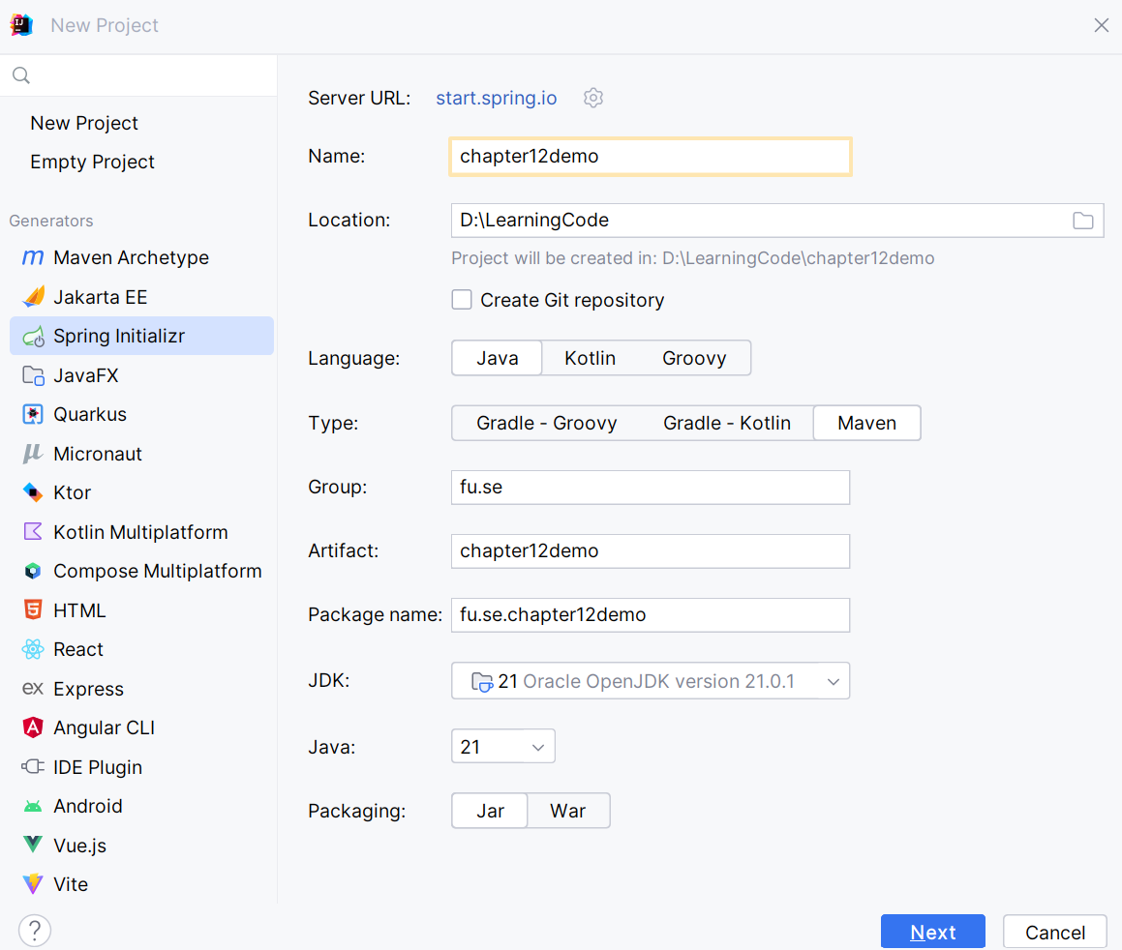

Step 02. Fill the information → Next

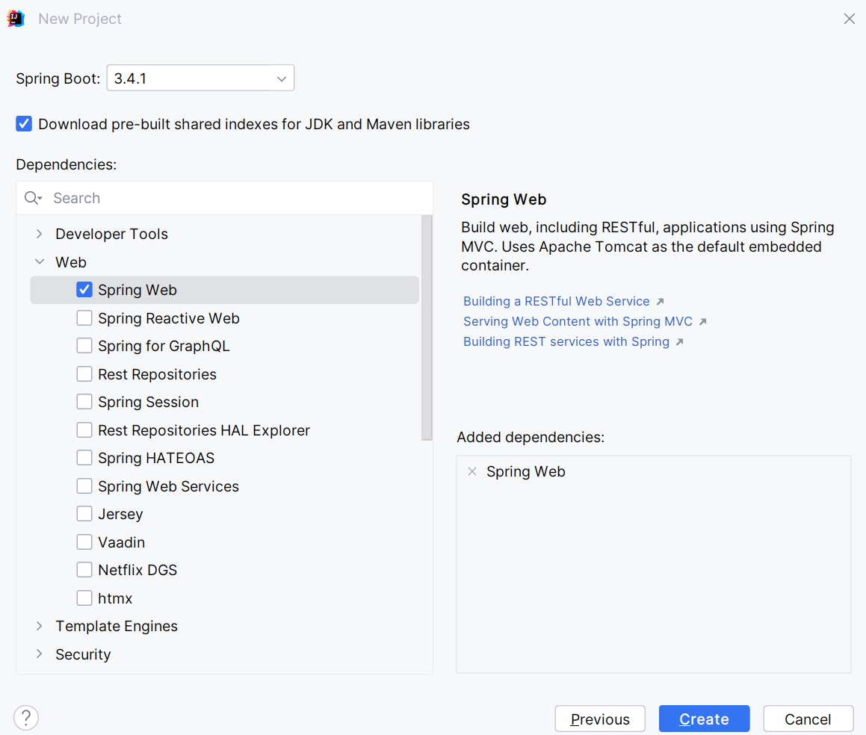
Step 03. Choose the dependency/dependencies → Click Create

Or you can using Spring Initializr project in https://start.spring.io/ then open this project in IntelliJ IDEA
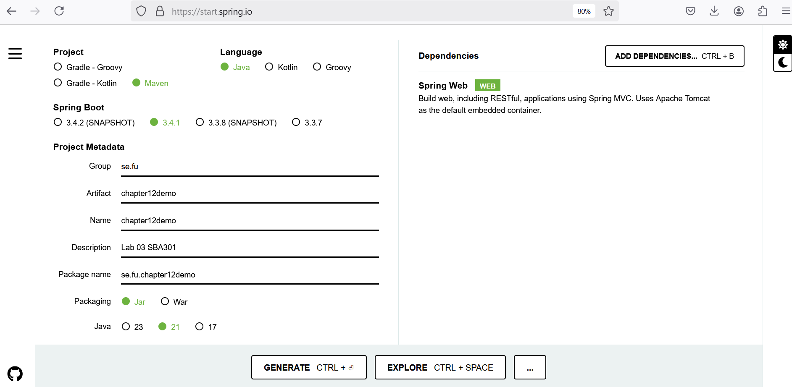

Step 04. Edit pom.xml, add the dependencies for
- Swagger Open API springdoc-openapi-starter-webmvc-ui
- Spring Data JPA for Paging and Sort data: spring-data-jpa
- Testing spring-boot-starter-test
<dependencies>
<dependency>
<groupId>org.springframework.boot</groupId>
<artifactId>spring-boot-starter-web</artifactId>
</dependency>
<dependency>
<groupId>org.springdoc</groupId>
<artifactId>springdoc-openapi-starter-webmvc-ui</artifactId>
<version>2.6.0</version>
</dependency>
<dependency>
<groupId>org.springframework.data</groupId>
<artifactId>spring-data-jpa</artifactId>
<version>3.4.0</version>
</dependency>
<dependency>
<groupId>org.springframework.boot</groupId>
<artifactId>spring-boot-starter-test</artifactId>
<scope>test</scope>
</dependency>
</dependencies>

Step 05. The structure of the Lab project
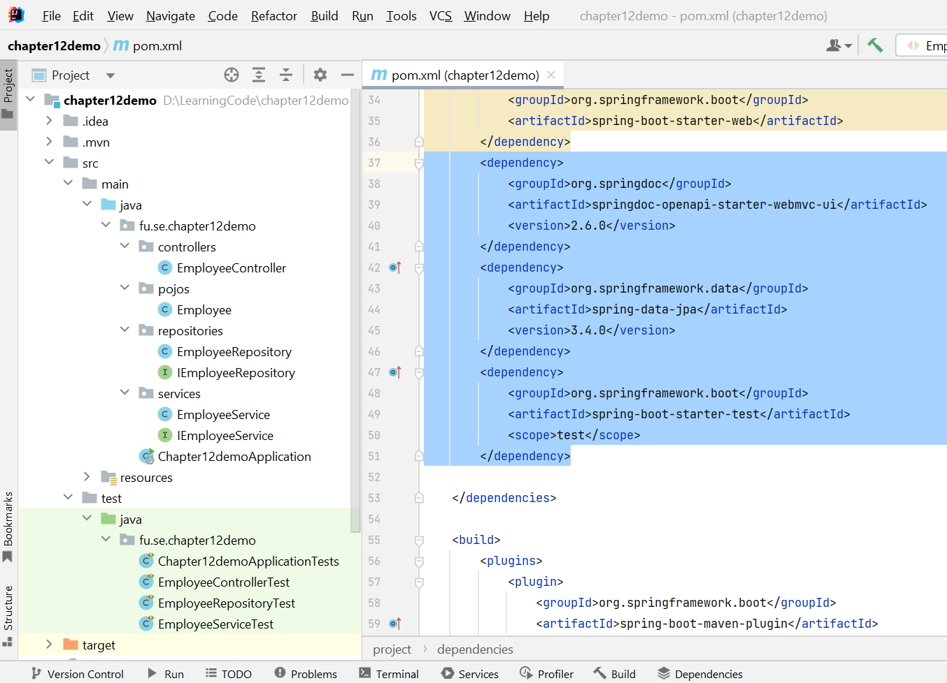

Activity 02: Implement RESTful API Employee Management with CRUD functions

Step 01. Create pojos package, then create Employee Entity
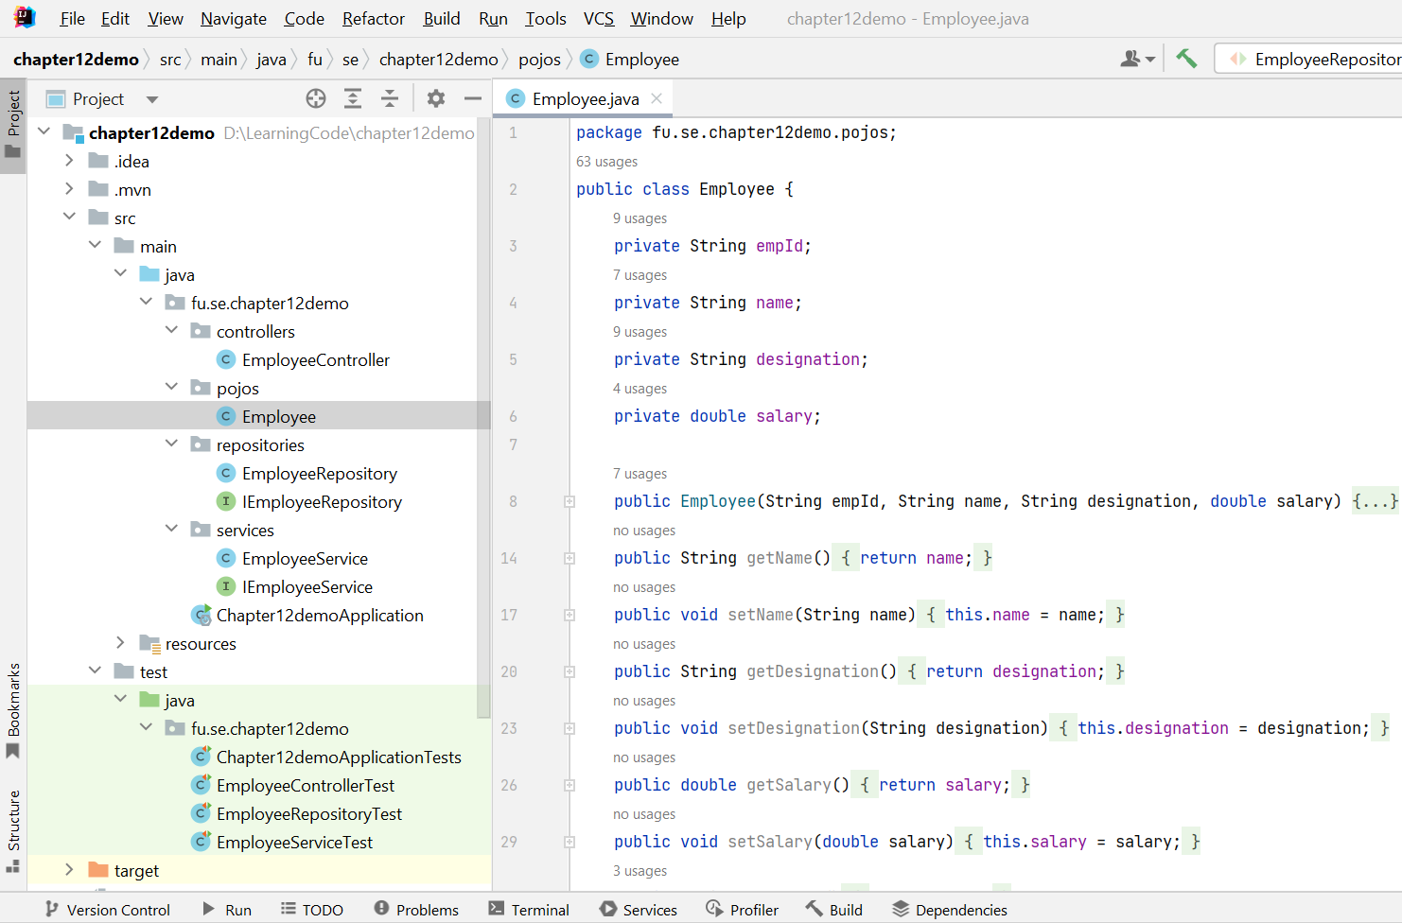
Step 02. Implement Repository by creating repositories package, IEmployeeRepository interface and EmployeeRepository class
- Implement methods for basic CRUD operations
- For in-memory paging and sorting without a database, override the findAll(Pageable pageable) method.
IEmployeeRepository interface should implement PagingAndSortingRepository <T, ID>
PagingAndSortingRepository repository fragment to provide methods to retrieve entities using the pagination and sorting abstraction. In many cases this will be combined with CrudRepository or similar or with manually added methods to provide CRUD functionality.
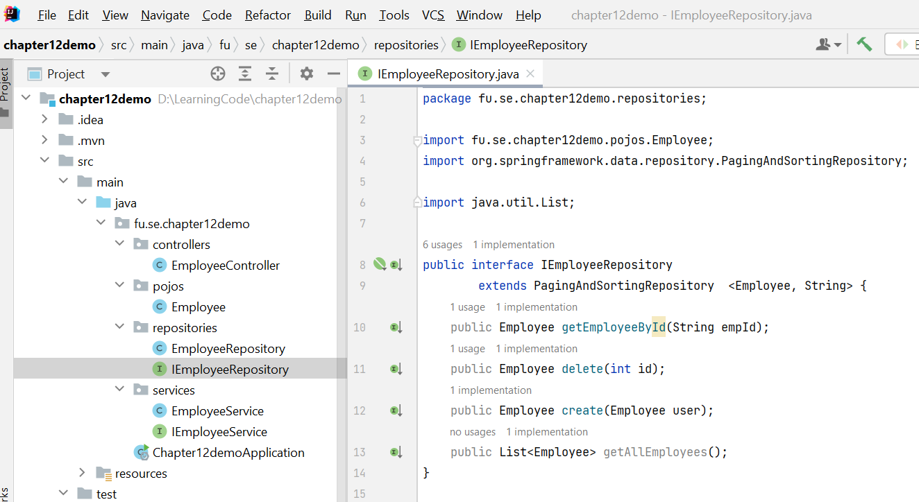

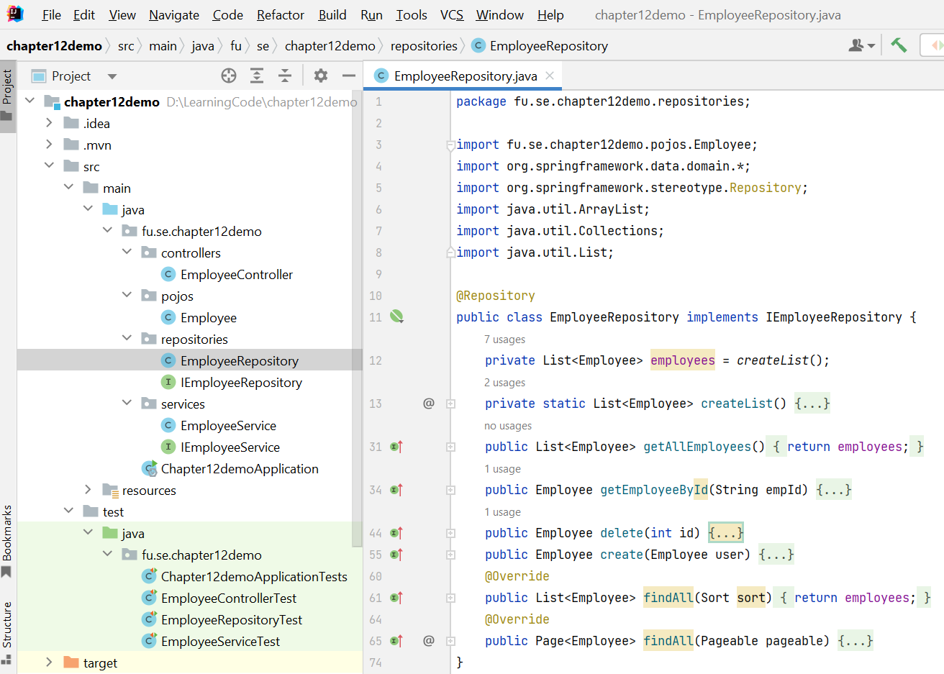

The functions in details
- List<Employee> createList()
- public List<Employee> getAllEmployees()
- public Employee getEmployeeById(String empId)
- public Employee delete(int id)
- public Employee create(Employee user)
- @Override
public List<Employee> findAll(Sort sort)
- @Override
public Page<Employee> findAll(Pageable pageable)

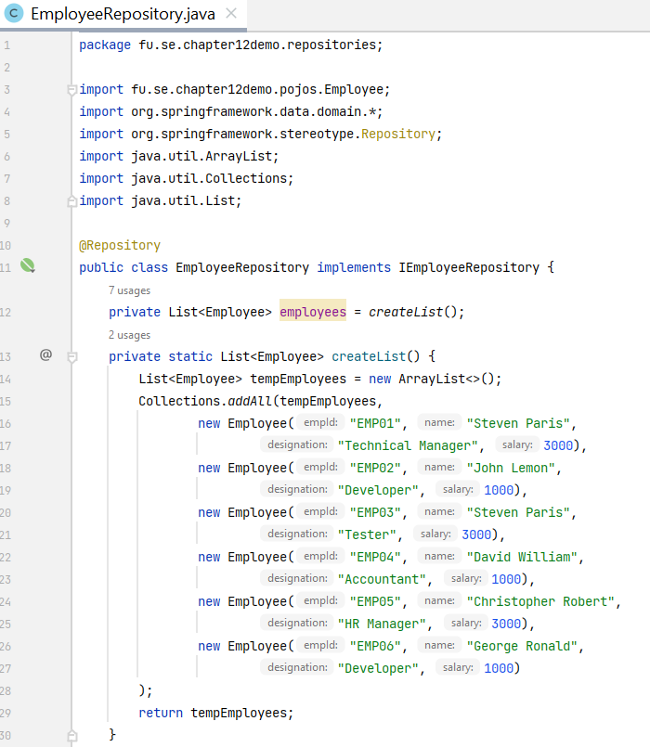

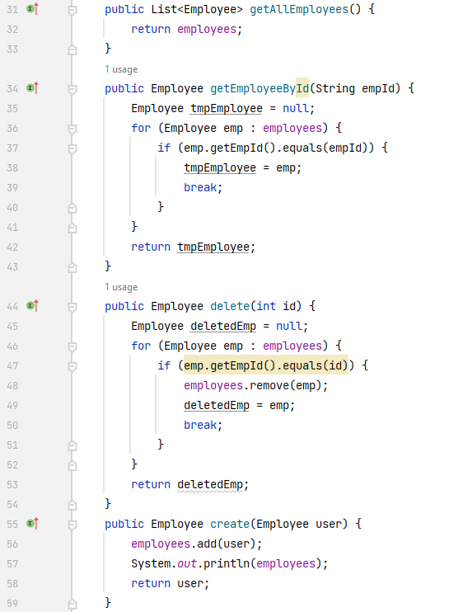
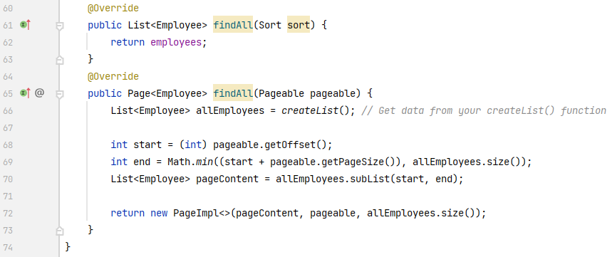

Step 03. Implement Service Layer includes: IEmployeeService interface, EmployeeService class in the services package.
- Implement business logic in your service methods.
- Use the EmployeeRepository to interact with the Repository (Data Layer)

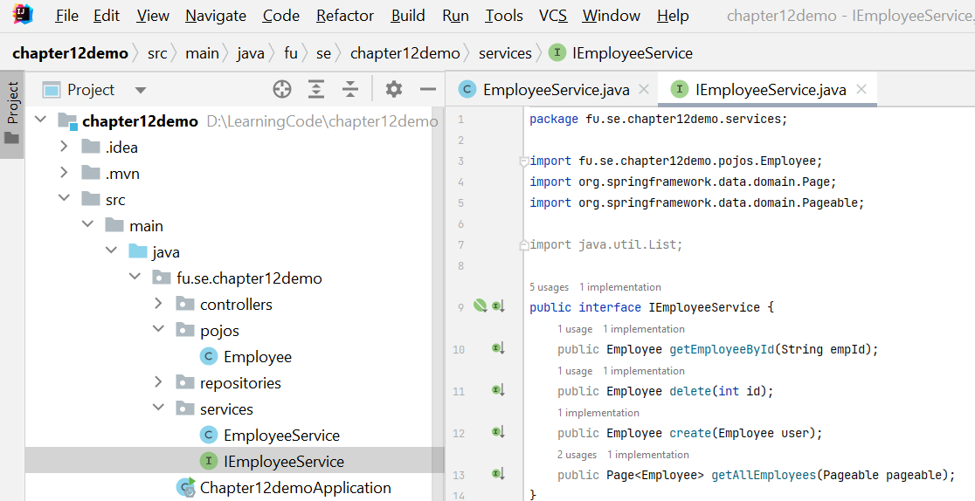

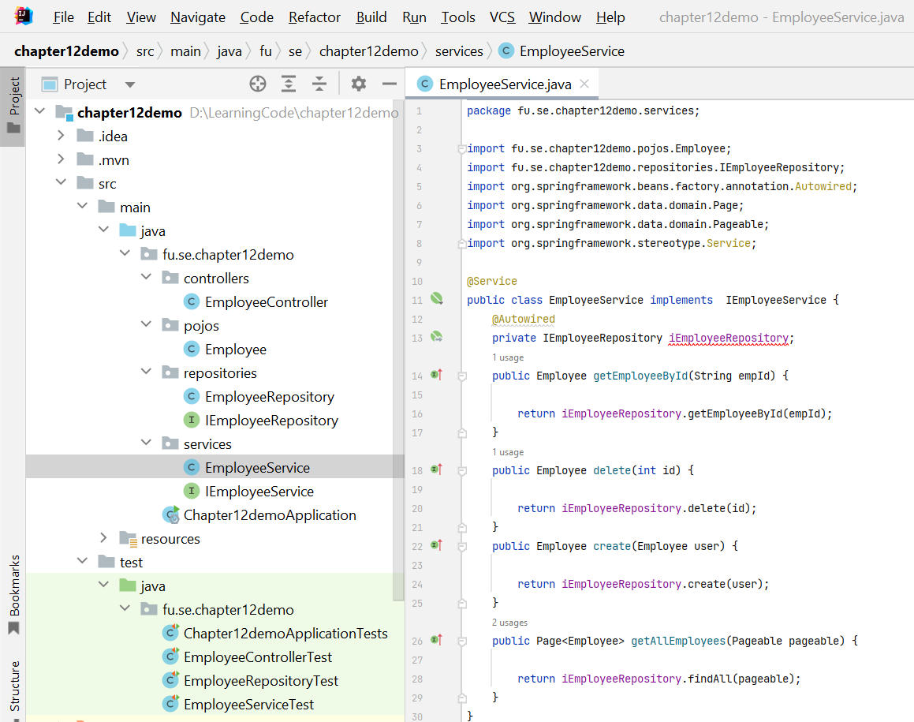

Step 04. Implement REST Controller

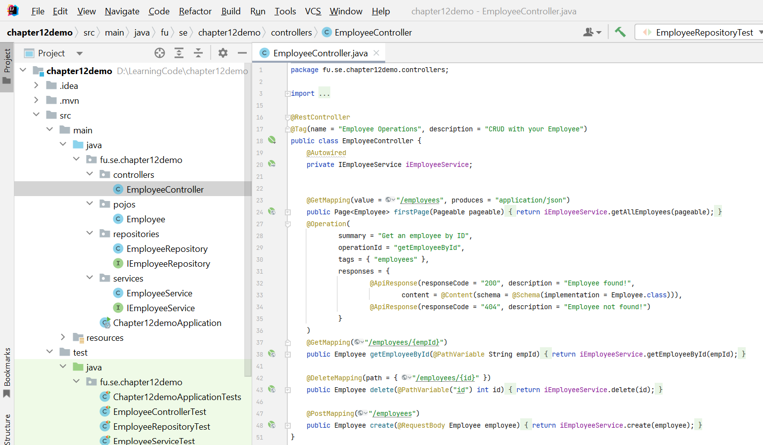

Step 05. The main entry point for Spring Boot application
The @SpringBootApplication annotation is a convenience annotation in Spring Boot that combines several annotations to simplify the configuration and initialization of a Spring Boot application.

When you use @SpringBootApplication, it automatically includes the following annotations:
- @EnableAutoConfiguration: This annotation tells Spring Boot to automatically configure your application based on the libraries on the classpath. For example, if Spring Boot detects that you have a database driver in your project, it will automatically configure a datasource.
- @ComponentScan: This tells Spring to scan the current package and its sub-packages for annotated components (such as @Component, @Service, @Repository, and @Controller) to register them as Spring beans.
- @Configuration: This marks the class as a source of bean definitions for the application context, meaning that you can define @Bean methods in this class.

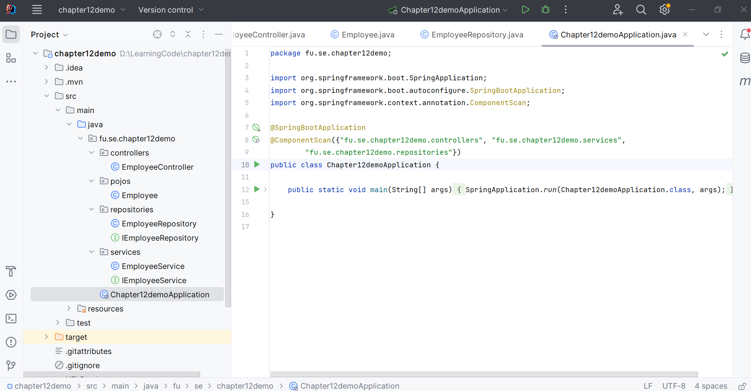

Step 06. Create Testing classes. Make sure that, the project has the following dependencies: spring-boot-starter-test, JUnit 5, Mockito, and AssertJ in pom.xml file.
Write tests
- Create test classes for your controller, service, and repository.
- Use @WebMvcTest for controller tests with MockMvc.
- Use @SpringBootTest for integration tests involving the full application context.
- Use @DataJpaTest for repository tests with an embedded database.

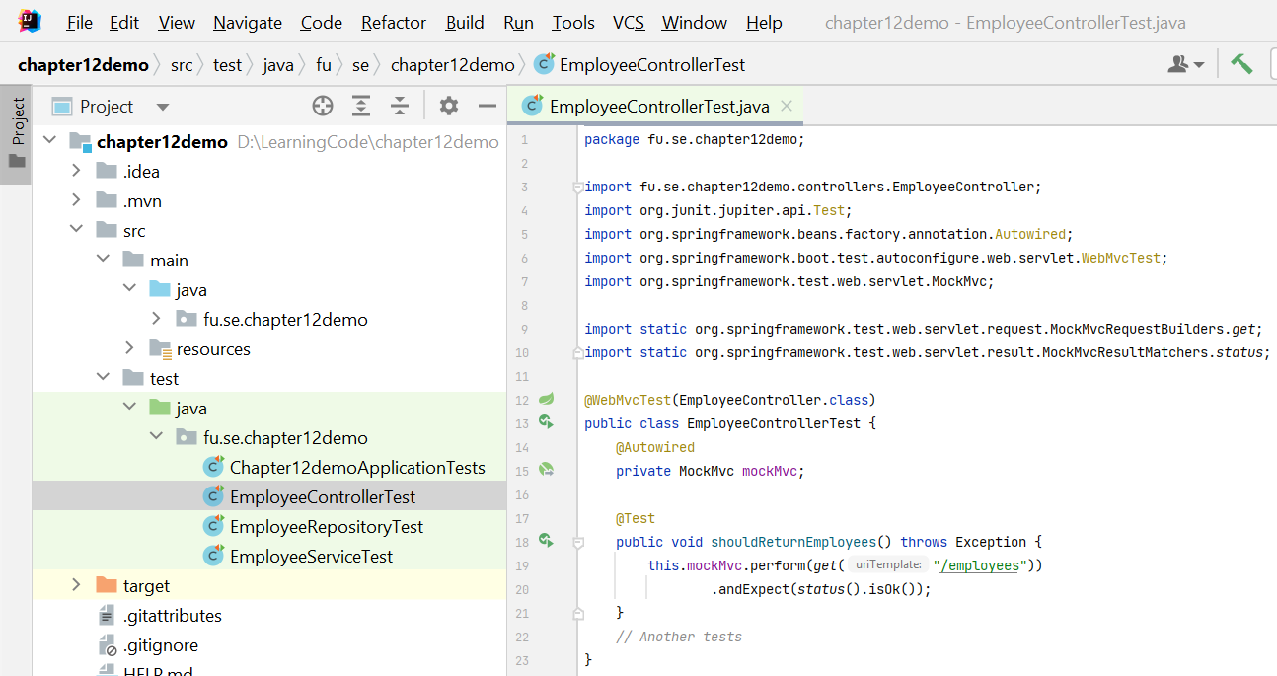

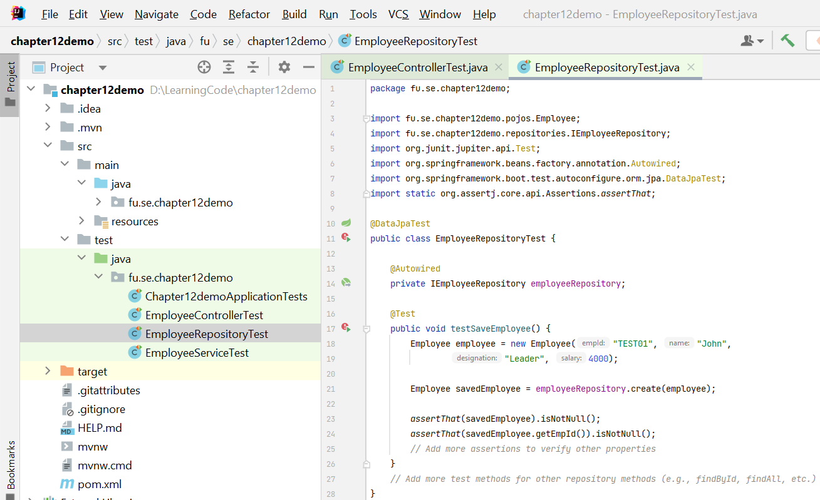

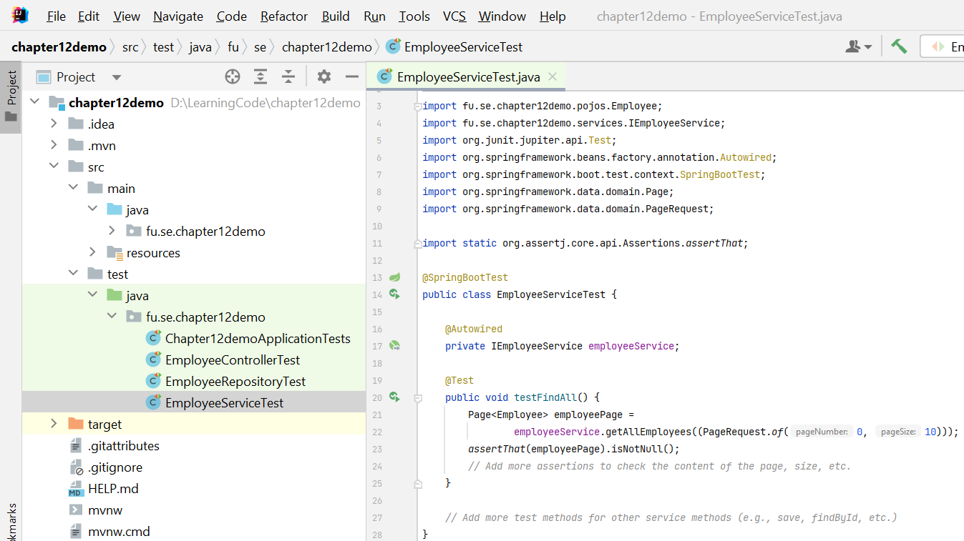

Activity 03: Run and test the RESTful API
Step 01. Run the RESTful API Project
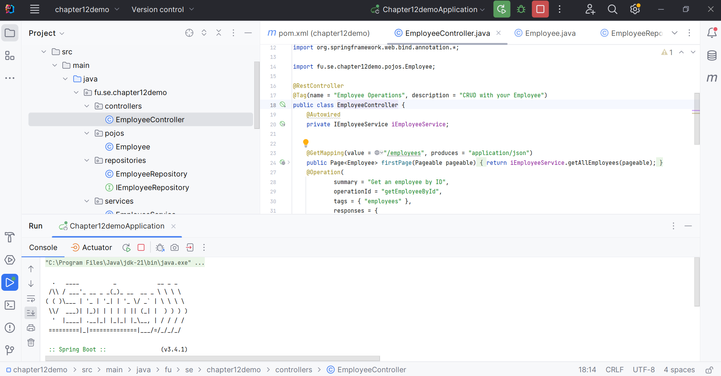
Step 02. Open http://localhost:8080/swagger-ui/index.html in your Browser
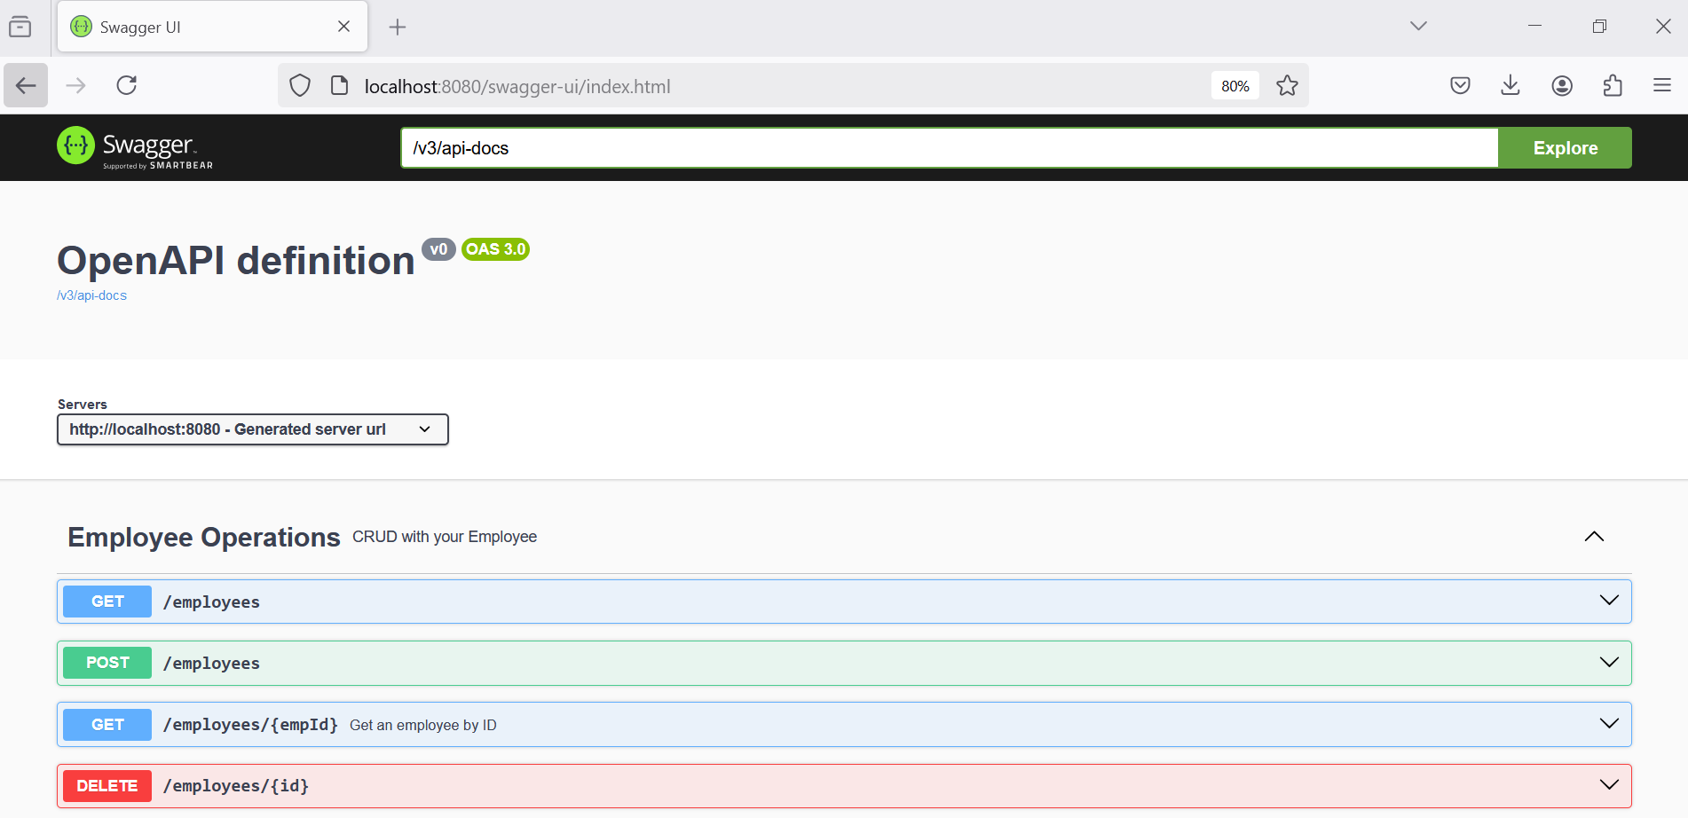

Step 02. Test the GET method with paging, provide page, size and sort parameters

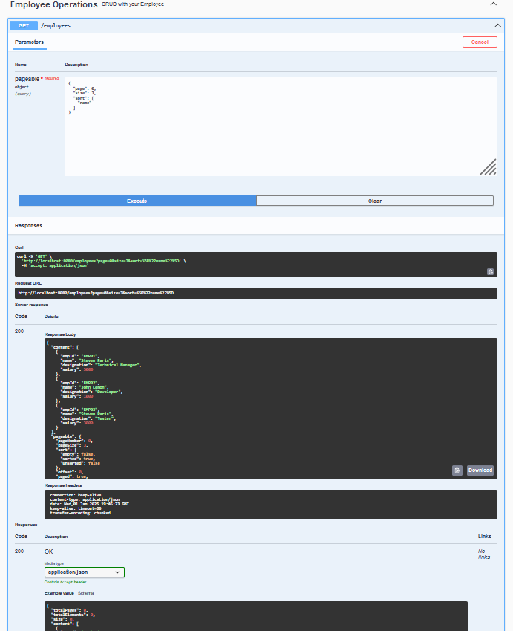

Step 03. Test the POST method for creating a new employee, provide empId, name, designation and salary parameters
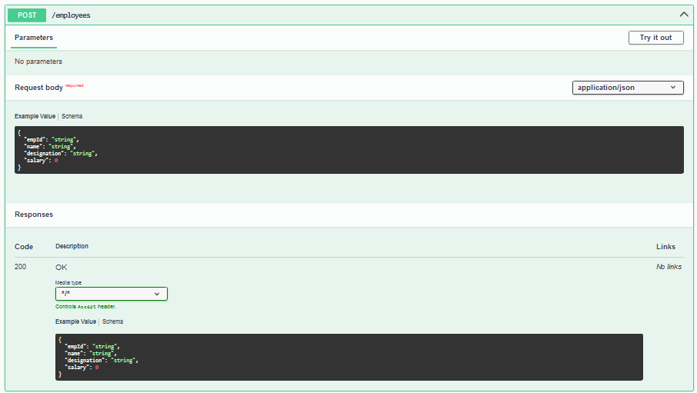

Step 04. Test the GET method for existing employee, provide empId parameter.
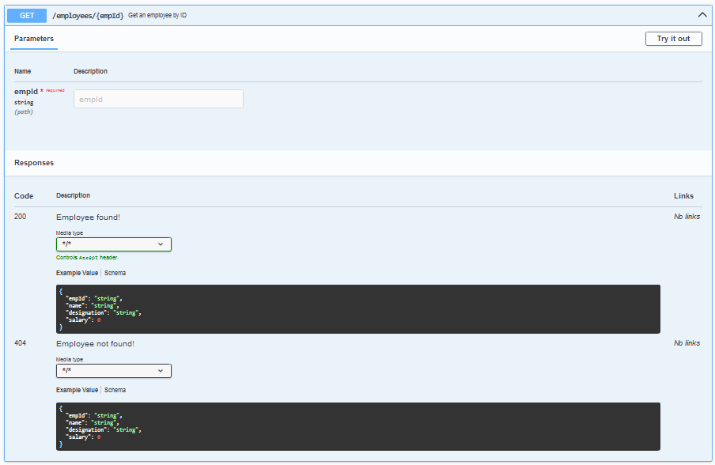
Step 05. Test the DELETE method for existing employee, provide empId parameter.
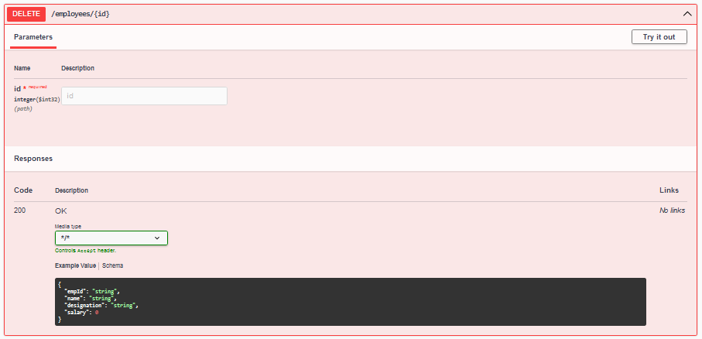

Note: The Schema of this application in Swagger UI
